Student comments on learning aids from interviews

36 students randomly selected from the BSc module were interviewed in Week 5 of the semester. During the interviews, students were shown screen shots from the some of the learning aids from a previous week. They were asked if they had used them, and what they thought about them. Here is a selection of comments made by students.

Text-based learning aid on ‘Basic repetition in Java’
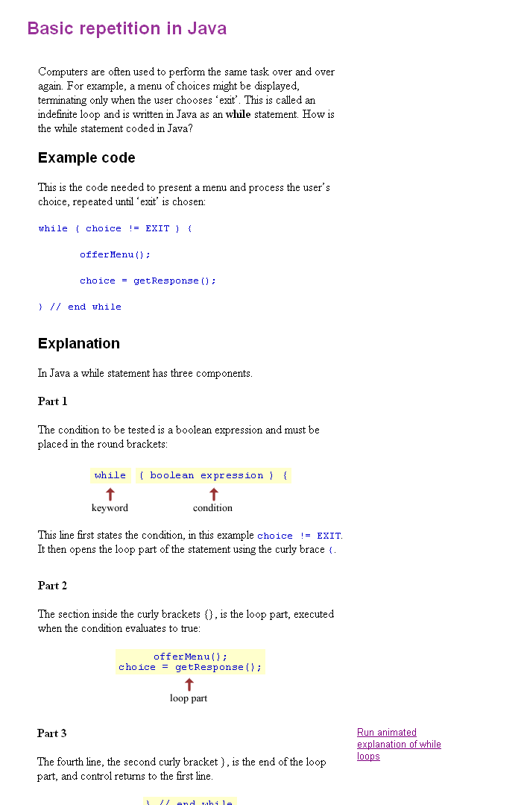

Student comments

“How did you use the learning aid?”

If stuck - use. Skip between book and learning aids. Use what I need.
Because done C++ copy the code out. Maybe refer to if need them. Explanations and sample code very good. Use them from home as well.
Read twice. Helped to do exercise.
Skim through it. Done programming before. Didn't need to use. Usually print out and go through at my leisure.

“How useful did you find it?”

Useful. Lots of hints.
Useful. Used it for the program.
Useful - but need practice as well.
Useful. Very good as a summary, then I read the text book.
Useful - could be improved - more visual images - more guidance on what to do.
Quite useful. When missed lectures, the learning aids show me where I'm going.

“Do you find it attractive?”

Yes. Easy to read and functional.
Clear, but not want to constantly read.
Would like larger type. Like colours.
Yes. Key words highlighted and illustrated. Easy to use and understand.
Simple. Good spacing. Like colour coding. Broken down into sections.

“Generally how useful do you find this type of learning aid?”

Good - better than reading a big book. Better on the eye.
Useful - fine if you understand it. Want more detailed examples.
Not useful - would prefer more teaching.
Very useful - use a lot.
Handy - can get them from home.
Very useful - particularly when not in class. Because they're online I can look at from home.

Multimedia learning aid on ‘While loops’
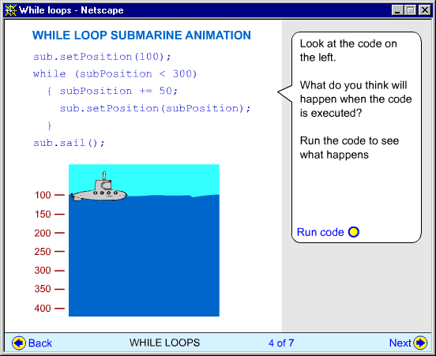
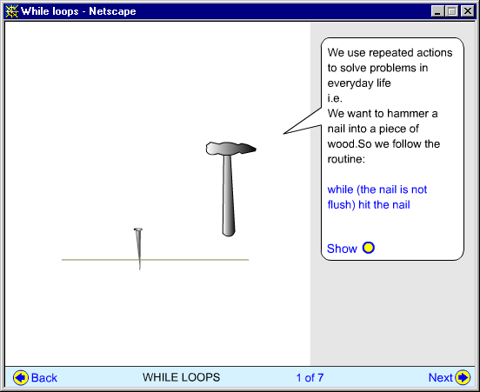

Student comments

“What did you think about this learning aid?”

Prefer to text - shows you how the code works. More appealing.
Very helpful. Interesting. Easy to understand.
OK - animation helps a lot.
Good - you can see the code - shows you what's going on when you press run. Interactive.
Shows what hammer does but would like to see the program behind it.
Good - shows step by step the program. Animations help a lot.
Really liked. Shows what code does. Really useful.

“Did it help you to learn about while loops?”

Yes because I was stuck before.
Yes - already familiar with while loops but helpful.
Yes. Explains things well plus is step by step.
Yes - made me understand it.
Yes. Good revision.
Book helped, but the LA did explain. Could see the loop.

“Do you find it attractive?”

Yes. More helpful than the writing - makes things happen.
Don't turn me on, but better than text.
Highlighted well. Good use of colour. Easier to read.
Very nice. Helpful. Easy to understand.
Like graphics. Like being able to see what happens.
Like. Simple. Window not too big. Examples not too complex.

“Generally do you find the animated learning aids useful?”

Useful. Helps you to understand. More detailed info. is helpful.
Yes - can see the results of the code.
Real examples you can manipulate.
Useful. Shows what code is actually doing.

The Quiz from the While loops learning aid

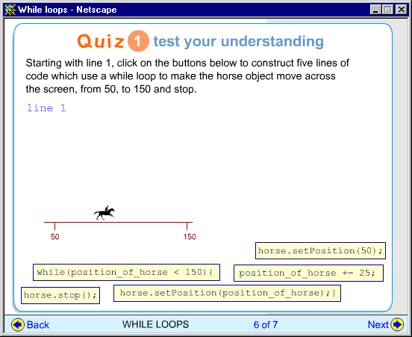

Student comments

Good helps you memorise what to put in the code
Don't do them. Don't like them.
Know how much you have understood.
Don't remember seeing them
If I saw one I would probably do it - to make sure I knew it
OK - some are helpful
Not seen or used
Can be helpful if you go through them.
Didn't like. Waste of time. Preferred to look at the code. Quizzes are the worst thing in it.
OK - helps you to look closely at the syntax of the code to get the right order
OK - not hard or complex enough
Good - reconfirms you know what you're doing
Very useful.
Like. Make sure you're learning. Self test.
Helpful. I always do them.
Good. Can test what you need to do. Gives you a chance to get it right. Helps to do program.
No reason for not doing. Focus on weekly exercises.
Good for students with no experience and also for refreshing. Would use as a refresher for a new area.

